**BC** Linear Mixed Effects Regression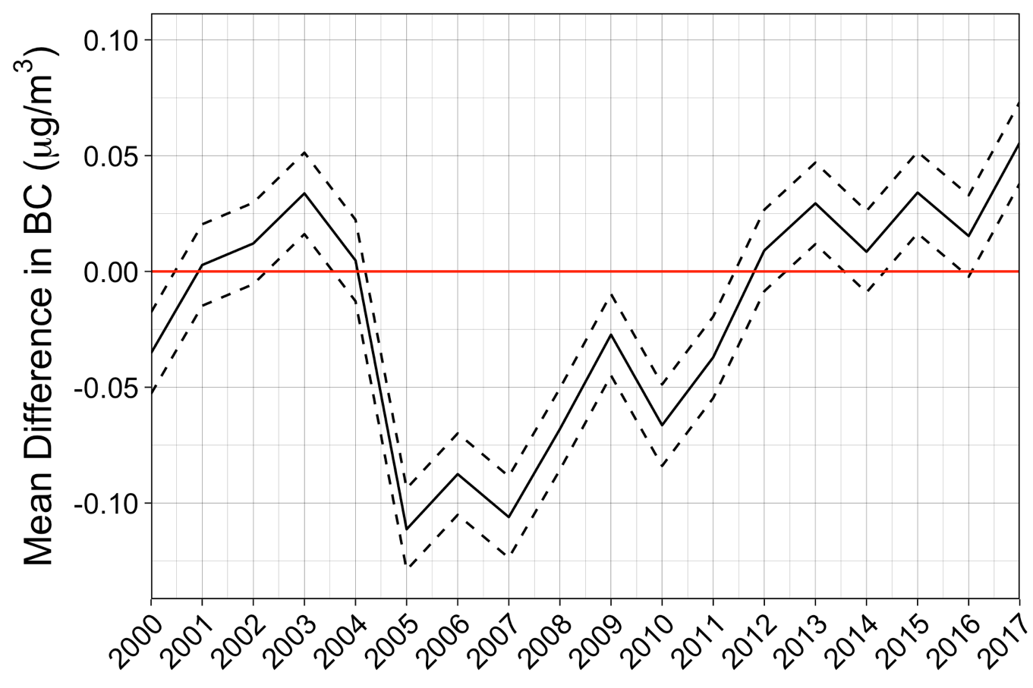

**

**

**

**

**

**

**

**NO3** Linear Mixed Effects Regression

**

**OM** Linear Mixed Effects Regression

**OM** Smoothed (GAMM with k = 10)

**OM** Smoothed (GAMM with k = 7)

**OM** Smoothed (GAMM with k = 5)

**SO4** Linear Mixed Effects Regression

**SO4** Smoothed (GAMM with k = 10)

**SO4** Smoothed (GAMM with k = 7)

**SO4** Smoothed (GAMM with k = 5)

**SOIL** Linear Mixed Effects Regression

**SOIL** Smoothed (GAMM with k = 10)

**SOIL** Smoothed (GAMM with k = 7)

**SOIL** Smoothed (GAMM with k = 5)

